**Note making: “Web application”**

* **Web application code name**: Visual studio code
* **Version :** 1.79
* **Date :**  4th July 2023

1. **Overview:**

Visual Studio Code (VS Code) is a lightweight and highly customizable source code editor developed by Microsoft. It provides a powerful and efficient environment for coding, debugging, and building various types of applications. Here is an overview of Visual Studio Code:

**User Interface:**

* VS Code features a clean and intuitive user interface with a minimalistic design.
* The main window consists of a sidebar on the left, an editor area in the centre, and a status bar at the bottom.
* The sidebar provides easy access to different views such as file explorer, source control, extensions, and more.

**Editing Features:**

* VS Code offers a rich set of editing features, including syntax highlighting, code completion, and intelligent code suggestions.
* It supports a wide range of programming languages and provides language-specific extensions for enhanced functionality.
* The editor includes built-in Git integration for version control and provides features like inline diff, staging, and committing changes.

**Customization and Extensions:**

* VS Code is highly customizable, allowing users to personalize their coding experience.
* Users can customize the editor's appearance, theme, key bindings, and configure various settings.
* It supports a vast ecosystem of extensions that extend the functionality of the editor. Extensions are available for themes, language support, debugging, source control, and more.

**Integrated Terminal and Debugging:**

* VS Code includes an integrated terminal for running commands and executing scripts without leaving the editor.
* It provides debugging support for various programming languages and frameworks, allowing users to set breakpoints, step through code, and inspect variables.

**Collaboration and Live Sharing:**

* VS Code offers built-in features for collaboration, enabling developers to share their workspace and code with others in real-time.
* It supports Live Share, a feature that allows multiple developers to work on the same codebase simultaneously.

**Productivity Tools:**

* VS Code provides several productivity tools to streamline development workflows.
* It includes features like IntelliSense, which offers intelligent code completion and suggestions based on the context.
* The editor supports task automation with the integrated task runner and build systems.
* It also has built-in support for popular source control systems such as Git, making it easy to manage code repositories.

**Platform Support:**

* VS Code is available on multiple platforms, including Windows, macOS, and Linux, ensuring a consistent experience across different operating systems.

1. **Key features:**

Visual Studio Code (VS Code) offers a wide range of features that enhance the coding experience and improve productivity. Here are some of the key features of VS Code:

**Lightweight and Fast:**

* VS Code is designed to be lightweight, ensuring fast startup and performance even when working with large codebases.
* It consumes minimal system resources, allowing for a smooth editing experience.

**IntelliSense and Code Completion:**

* VS Code provides IntelliSense, a feature that offers intelligent code completion and suggestions based on the code context.
* It helps developers write code faster and with fewer errors by providing relevant suggestions for functions, variables, and libraries.

**Rich Language Support:**

* VS Code supports a wide range of programming languages out-of-the-box, including popular languages like JavaScript, Python, C++, and Java.
* It provides syntax highlighting, code formatting, and language-specific features to enhance productivity for each supported language.

**Extensibility and Customization:**

* VS Code is highly extensible, allowing users to enhance and customize their coding environment with extensions.
* The VS Code Marketplace offers a vast collection of extensions contributed by the community and developed by Microsoft, providing additional features, language support, and integration with various tools and frameworks.

**Integrated Terminal:**

* VS Code includes an integrated terminal that allows developers to run commands, scripts, and interact with their applications without leaving the editor.
* It supports different shells (e.g., PowerShell, Command Prompt, Bash) and provides a seamless development and debugging experience.

**Git Integration:**

* VS Code has built-in Git integration, making it easy to work with version control systems.
* Users can view changes, stage, commit, and push code directly from the editor, facilitating collaboration and code management.

**Debugging Support:**

* VS Code offers a powerful debugging experience for various programming languages and frameworks.
* It allows users to set breakpoints, step through code, inspect variables, and interactively debug their applications.

**Task Automation and Build Systems:**

* VS Code supports task automation and build systems, enabling developers to define and execute tasks such as compiling code, running tests, or deploying applications.
* It provides a flexible framework for automating repetitive tasks and integrating external build tools.

**Live Share (Real-time Collaboration):**

* VS Code's Live Share allows developers to collaborate in real-time, enabling multiple developers to work together on the same codebase, regardless of their physical location.
* It allows for sharing of the development environment, code editing, and debugging sessions, improving collaboration and enabling pair programming.

1. **Benefits:**

* Visual Studio Code can be used to write, edit, and debug the code, all in one place. VS Code supports many programming languages, for which a developer does not require Web Support. Everything can be found in its built-in multi-language support.
* A developer can rely on Visual Studio Code for all kinds of development, as long as they pair it with the right tools. VS Code comes with built-in support for JavaScript, Node.js, and TypeScript. If this is not enough, one can easily add the necessary support for languages like Python, C#, PHP, Java, and many more by installing their extensions.

1. **System requirements:**

* 4 vCPU and 16 GB of RAM recommended. Hard disk space: Minimum of 850 MB up to 210 GB of available space, depending on features installed; typical installations require 20-50 GB of free space. We recommend installing Windows and Visual Studio on a solid-state drive (SSD) to increase performance.

1. **Tools:**

* HTML
* Time.ess
* Myapp.java script

1. **Structure and Organize:**

Visual Studio is an integrated development environment (IDE) that provides a range of tools for building web applications. When creating a new web application project in Visual Studio, the main structure of the project will typically include the following files and folders:

**index**.**html**:

This file is the main entry point for the application and is responsible for rendering the initial HTML content in the user's web browser. It typically includes references to CSS and JavaScript files that provide styling and interactivity to the application.

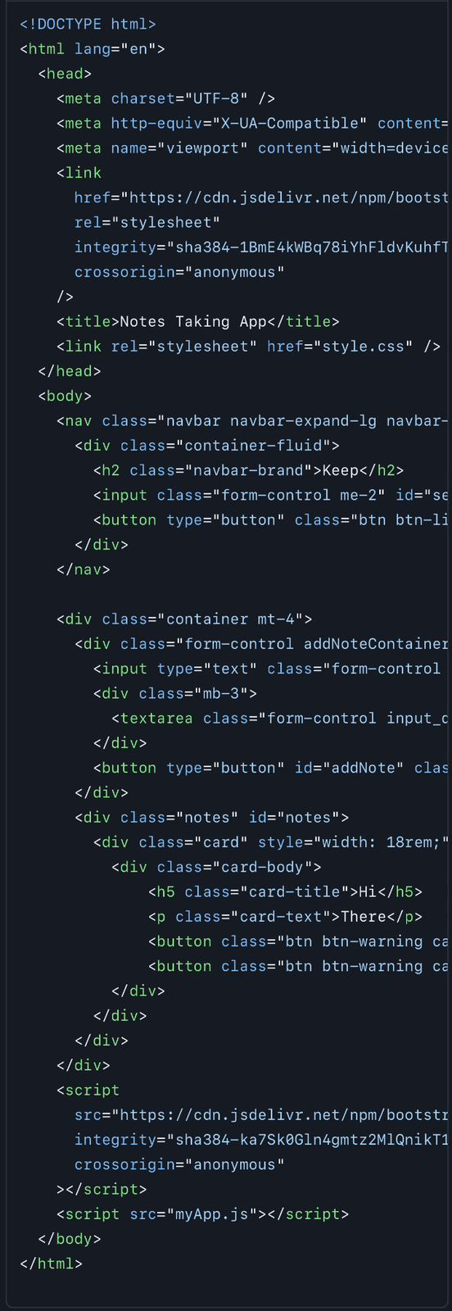

**css/ folder:** This folder contains one or more CSS files that define the styles and layout of the application's HTML content. These files are typically linked to from the index.html file.

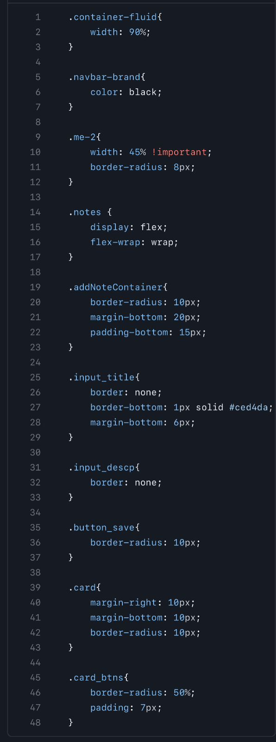

**js/ folder:** This folder contains one or more JavaScript files that provide interactivity to the application, such as handling user input and updating the HTML content dynamically. These files are also typically linked to from the index.html file.

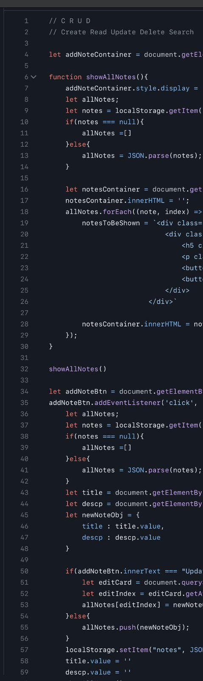

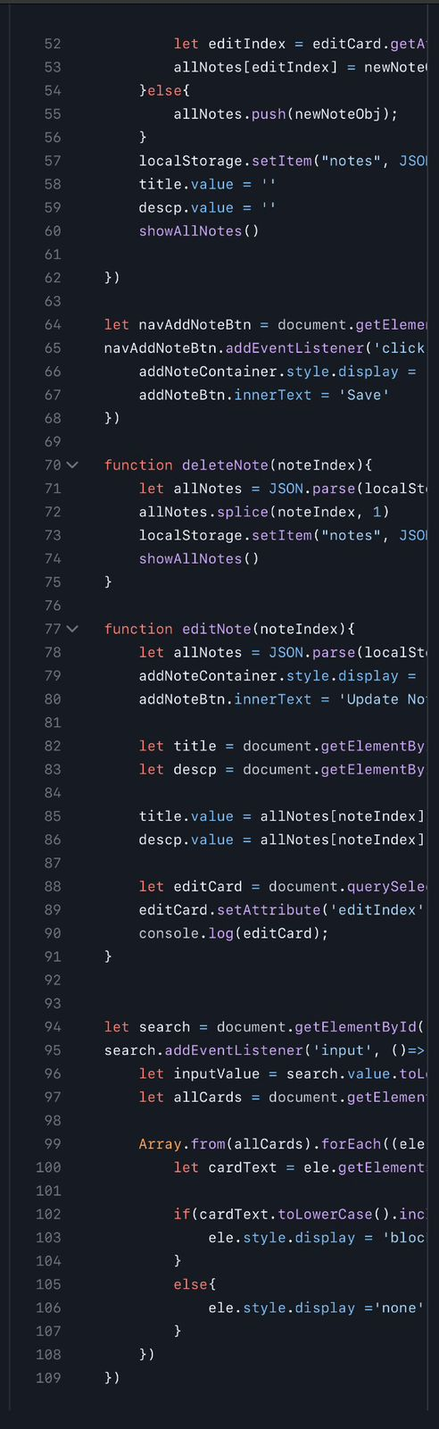

**img/** **folder**:

This folder contains any images or other media files used by the application, such as logos or icons.





1. **Process:**

Involves following steps:

**Creating a New File:**

* Open VS Code and create a new file by clicking on "File" in the menu bar and selecting "New File."
* Alternatively, use the keyboard shortcut Ctrl+N (Windows/Linux) or Cmd+N (Mac) to create a new file.

**Writing Code:**

* Start writing your code in the newly created file.
* VS Code provides syntax highlighting and code formatting for various programming languages, making it easier to write clean and readable code.
* Take advantage of IntelliSense to get code suggestions, auto-completion, and parameter hints as you type.

**Saving the File:**

* Save your code by clicking on "File" in the menu bar and selecting "Save" or using the keyboard shortcut Ctrl+S (Windows/Linux) or Cmd+S (Mac).
* Choose a location on your system to save the file and provide a meaningful file name.

**Opening Existing Files:**

* To open an existing file, click on "File" in the menu bar and select "Open File" or "Open Folder."
* Navigate to the file you want to open and select it.

**Managing Multiple Files**:

* VS Code allows you to work with multiple files simultaneously in a single window.
* Open additional files by clicking on "File" in the menu bar and selecting "Open File" or using the keyboard shortcut Ctrl+O (Windows/Linux) or Cmd+O (Mac).
* Switch between open files using the tabs at the top of the editor window or with the keyboard shortcut Ctrl+Tab (Windows/Linux) or Cmd+Tab (Mac).

**Refactoring and Editing:**

* Use VS Code's editing features to refactor and modify your code.
* Rename variables, functions, or classes by right-clicking on the name and selecting "Rename Symbol" or using the keyboard shortcut F2.
* Format your code automatically by right-clicking and selecting "Format Document" or using the keyboard shortcut Shift+Alt+F (Windows/Linux) or Shift+Option+F (Mac).

**Running Code:**

* VS Code provides various ways to run your code, depending on the programming language and framework you are working with.
* For interpreted languages like Python or JavaScript, you can use the integrated terminal to execute your code directly.
* Configure launch configurations to run and debug your code using VS Code's debugger.

**Debugging:**

* Debug your code using the VS Code debugger.
* Set breakpoints by clicking in the left margin of the code editor or by using the F9 key.
* Launch the debugger using the Debug sidebar or by pressing F5.

**Source Control:**

* Utilize VS Code's built-in Git integration to manage version control for your code.
* Stage changes, commit code, and push or pull from remote repositories directly from the editor.
* Use the Source Control sidebar to view and manage your version control operations.

**Extensions**:

* Extend the functionality of VS Code by installing extensions.
* Explore the marketplace to find extensions that provide additional language support, debugging tools, code snippets, linters, and other features.

**Saving and Closing:**

* Save your changes regularly by using the Save command or the keyboard shortcut Ctrl+S (Windows/Linux) or Cmd+S (Mac).
* Close files or exit VS Code by clicking on the "X" button in the tab or selecting "Close" or "Close Window" from the File menu.

While we click “Run” we get to see three options, in web application (chrome) if we run we get notepad which we can create, read, updates and delete which is the final output. Where we can add number of notes.